Roaches School Network
Assessment Policy

Assessment at all stages is based on a teaching and learning cycle where we;
- Identify needs
- Plan and design learning
- Facilitate learning
- Assess learning
- Evaluate
Initially attempts are made to access previous school data on the individual child. However, this is not always available or up to date since some of our pupils have been out of the education system for a prolonged period. In addition to this some children arrive having recently experienced a sustained traumatic event that has a significant negative impact on their previous learning.
Lower School
It is felt that it is inappropriate for our pupils to sit formal tests to gather a baseline assessment.
A holistic approach is used where teacher’s broader observations can accurately capture their development better than any single baseline assessment, particularly at such a tender age.
When a child has settled into our environment a reading and spelling assessment is completed and simple informal Maths questions are verbally relayed to ascertain appropriate starting points.
Upper School
Pupils are formally assessed within 6 weeks of entry to the school to provide a baseline assessment, from which teaching staff can identify where children are in their learning and what their next steps are.
Assessment and Progress
There will be a combination of formative, assessment for learning and summative assessments as each child moves through The Roaches School. In addition to this, there are the statutory KS2 assessments, which all Year Six pupils are encouraged to sit. These statutory tests will be reported as a scaled score, where 100 is the expected national standard.
Assessment for Learning (Afl): Assessment is an integral part of the learning process and as such, Afl will be present in lessons as an on-going and continuous process. Ongoing teacher assessments with pupils will be based primarily on observation of daily activities and events.
Summative Assessment: The teachers make summative assessments at the end of a unit of work. These will take a variety of forms, depending on the nature of each subject and the ability of the pupil.
Summative assessments:
- Provide a summary judgment about each pupil at a specific point in time
- Show what pupils can achieve without support
- Inform any subsequent intervention activities.
- Formative Assessment: This is conducted by teachers during the learning process in order to modify teaching and learning activities to improve pupil attainment to the end goal of passing official examinations.
Expectations
All children at The Roaches School are assessed against age-related expectations. We establish where each child would come on the milestone scale and track progress accordingly throughout their time with us. It must be noted however that most of our pupils are performing at least 2 years below age related expectations on arrival. This is not surprising considering where they have come from and the negative experiences they have faced and continue to face.
The Roaches School Milestone Assessment Policy, which has evolved in conjunction with The Leek Education Partnership (LEP) is used and shown below.
Children work through objectives relevant to their ability and progress from an entering level to a mastering level.
Entering – pupils are beginning to grasp some of the main ideas and skills in a unit of work. The work does not yet consistently meet the expected standard for this age group. There may be support needed.
Developing – pupils have grasped some of the main ideas and skills in a unit of work, others require development.
Securing – pupils have a secure understanding of the main concepts and skills when applied to familiar contexts. They have some independent skills within the framework of the curriculum.
Mastering – Pupils have demonstrated comprehensive understanding of all concepts and skills and can apply these to new situations without help.
KS4 Assessment
To extend learning further, pupils are given the opportunity to complete Entry Level assessments in English, Maths and Science. This system is ideal to build confidence and provide the building blocks to access the higher-level GCSE examinations.
Entry Level Qualification – used for our lower level ability pupils to provide them with a recognised qualification offered in schools throughout the country that gives them the opportunity to achieve a certified award.
The Entry Level qualification encompasses 3 categories – Level 1, Level 2 and Level 3. Within these categories are sub-levels – 1.2, 1.5 and 1.8 and continuing in this vein throughout subsequent categories.
The Entry Level certificates allow our pupils to receive an award that fairly represents their attainment and reflects the skills that they have demonstrated.
GCSE Qualification – the new GCSE examinations in English Language and Mathematics started in September 2015, followed by Science, Citizenship, Geography, Physical Education and Art & Design in 2016. The new GCSEs are more demanding and are purely examination based. This is a huge shift from previous examinations and new schemes of work and exam coaching techniques were devised as a result. A new grading scale that uses the numbers 1-9 to identify levels of performance, with 9 being the top grade was also introduced.

Ofqual GCSE Grading Conversion Table 2017

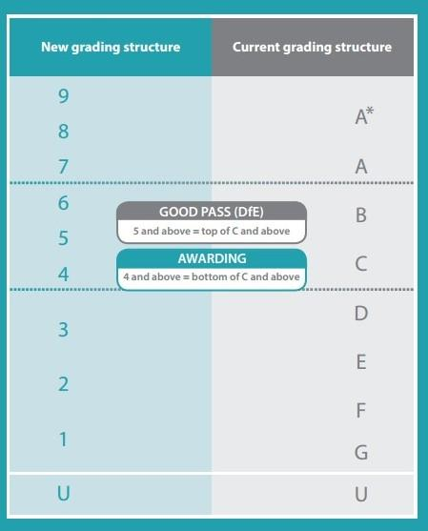

Pupils at The Roaches School are selected and taught the skills required to successfully pass these examinations based on prior attainment and ability and can sit mock examinations in November, so staff can assess performance and target intervention before the official examinations in the summer.
Determining Progression
Pupils will be expected to perform at an assessment grade that is consistent with their prior attainment. It is important to note that assessments gradually become more challenging as pupils move from year to year, so pupils can continue to achieve and make or exceed expected progress.
All assessments are moderated by subject specialists and a sample range is selected for external standardisation, through our links with AQA English Hubs, OCR Maths Hubs and LEP.
Tracking Progress: teaching staff will enter assessment data into SIMS using our data tracking system.

To be reviewed annually - Reviewed September 2023

